Resident’s Assignment

Resident’s name: Ramneet Kaur Taneja

Practice Task Name: Student Profile

Faculty: Sameera Sood

PRT No.: 5

Date of giving Assignment:

Date of submission of Assignment:

Task/ Questions: Describe the student, including both characteristic and unusual behavior, using the prompts provided in the Student Profile Guidelines in the Practice Teaching Handbook

Purpose/ Rationale of choice: I am shadowing Manan Sachdeva, he is 7 years old boy. His father is a doctor and his mother is working too, as both are working so they spend only 2-3 hours in the evening with Manan. Once I attended Open day PTM for Manan – from which I could make out that parents are very concerned about his studies. I choose him because I found despite of having a very good family background, he appears distracted mostly. Although he looks very sincere and he is obedient too, However I realized he always stays in his own world, while teacher is talking or discussing something he just get lost in his world of imagination (Which I could see he smiles and talks with his own self), then he don’t listen anything, and when it comes to act anything related the teacher’s instructions, may be in academically or physically he ask for the instructions again and say I don’t know what to do now? That’s the curiosity in me what’s holding him back and if doesn’t he pay attention to the teachers, so what is it in which he is not interesting? Also I wanted to choose a child whom I can work upon, as I had an option to choose an intelligent child as well, but I wanted to check my ability as well to handle a child in such situations.

Profile

Physical Presence and Gesture: Manan is a tall (comparative to his age group), slim and fair in complexioned. He has short hairs, and always has a smile on his face. His eyes are black, zed black and seems very deep to me, he appears very calm and sensible within. He behaves very well till the time he feels someone is observing him or he is getting noticed, but the moment he enter into his own world he just get lost and then he doesn’t realized where is he at, that time we need to literally call him by his name to get him out of his world. If we call all the children together he won’t pay attention to us. He always keep his hands busy with something, may be with a pencil, eraser, book any paper or sharpener, if none of it is available he will shake his legs or hands and sometimes tap with hands on the table. Even if teacher is giving any instruction he will not listen, he would rather write on the table and then erase it.

When he is I the play ground he keen to lean on someone, he hugs his friends, (he prefers to be with a boy) or hold their hands. He can run fast, when it comes to race, he always wants to come first. For position sake he sometimes try to cheat his friends, because he is too young and innocent, he often gets caught while cheating and accepts it as well afterwards. I think he a confident child but most of the time overconfident, which leads him to face disappointment sometimes. His level of energy in the field is always high, in comparative to classroom; during class he acts very calm.
His pace is slow in approach of studies, however he won 1st prize in table tennis, which shows his interest towards sports, he showed his medal in the class and shared it in the class that – “the way we need to study hard to come first, we need to hard-work in sports as well, this is how I got the medal”, He also said he used to spend 2hrs, every day to practice Table tennis, he love to play it. He conveyed a message as well that by doing hard-work we can achieve a medal in studies too (which I felt was his parents voice)

Disposition and relationship with Children and Adults: Manan’s attitude towards learning is positive, he shows interest to learn, and express him freely sometimes. Sometimes he raises his hands to answer the question asked, but when his turn comes he answer it wrong or out of the content. I have observed he always eager to participates or contribute in the class, sometimes reaches to appropriate answers however most of the time talks irrelevance but his approach to contribute is there all the time consistently.
Manan is friendly with everyone, he is a child who never starts any quarrel, yes he gets disagrees at some point, also tries to express himself as well, that represents him quiet fair and honest in his approach. He gets convinced easily and agrees with his friends easily too. Whenever he gets irritate from someone in the class, he first bear the problem and later complaint but always prefers to go to the teacher, very often act on his own, which shows he pays respect and attention to himself as well as to others. His Emotional tone is serene. In a group he co-operates with everyone, and gets dominate very easily, still he has recognition in the group. His ideas get influenced very easily by others. During the day his pace remains the same in the class. His friends take him very easy to handle, as he doesn’t trouble much. He also gets treated very lightly, such as let it be sort of. As he always wants to be popular amongst his friends so he shows off as well, he prefers to carries branded things. His bag, bottle and tiffin show the same.

Ways of learning and thinking: As Manan shows interest in learning, and it appears that he is listening attentively, however when it comes to articulate anything may be story, any concept discussed in the class or his own thoughts, his sequencing usually goes haywire. Whereas his mathematical approach is very strong his concepts in mathematic are very clear, he can easily take backward or forward jumps with different strategies. As per my observation he is visual learner, as he only remember what he sees rather than what he hear. I think that’s the reason he face difficulty in articulation. While doing maths because he sees what teacher has model on the board, same pattern he follows. While doing language or theme, although things are around him he faces difficulty in making connections. He takes time to understand logics, as we were doing story sequencing, where he was sitting next to me, he was not able to do the same, and with my little help he did that. His reading interests are not much, his DRA level (Developmental Reading Assessment) is 16, which should be 28 by the end of the session, although he reads RP books (reading program books), but it hasn’t increased in this class yet.

What does artifacts says about child: He writes very neatly, formation of letter goes very well however spelling and grammatical mistakes he usually makes. His thought process is quiet slow or limited, this I am saying on the evidence of his Narrative writing samples, where they follow the following steps:
- Mind Map of the Topic
- First draft
- Revisiting ( checked by teacher and teacher’s feedback)
- Check list
- Final draft
Despite of reiterates all the steps, his final draft was just as his first draft, he couldn’t add more details, which shows his limited thoughts and limited ability to articulate the event and lacks clarity, although he did his check list honestly, and accepted where he has made mistakes. Samples are as below:
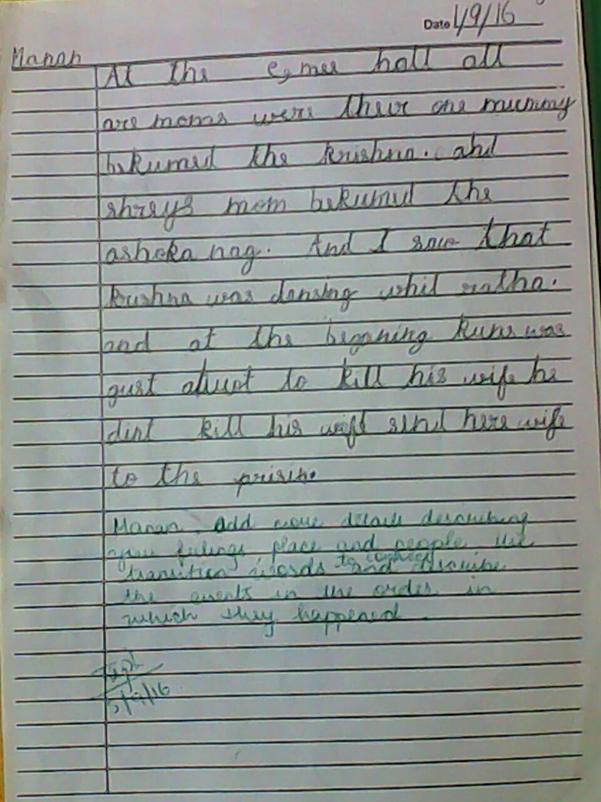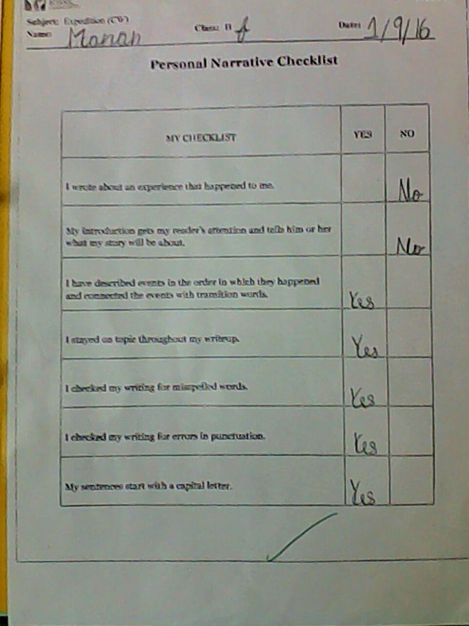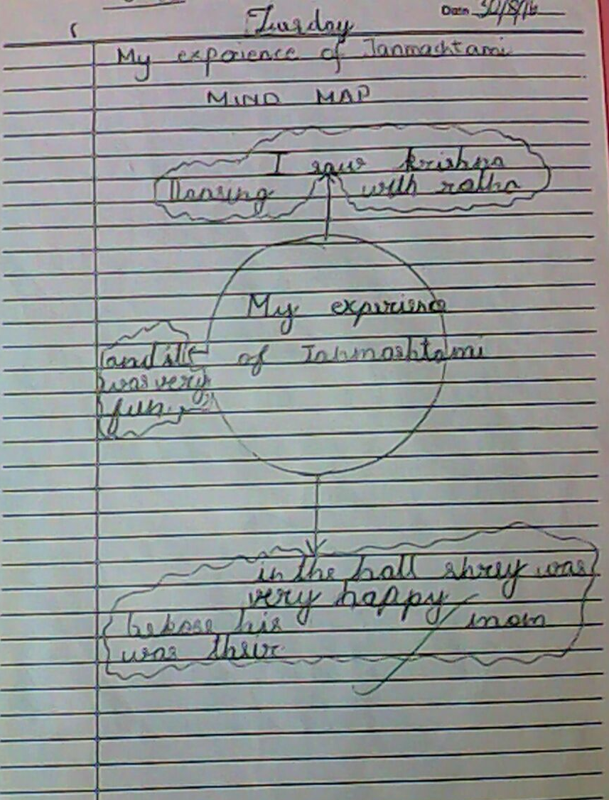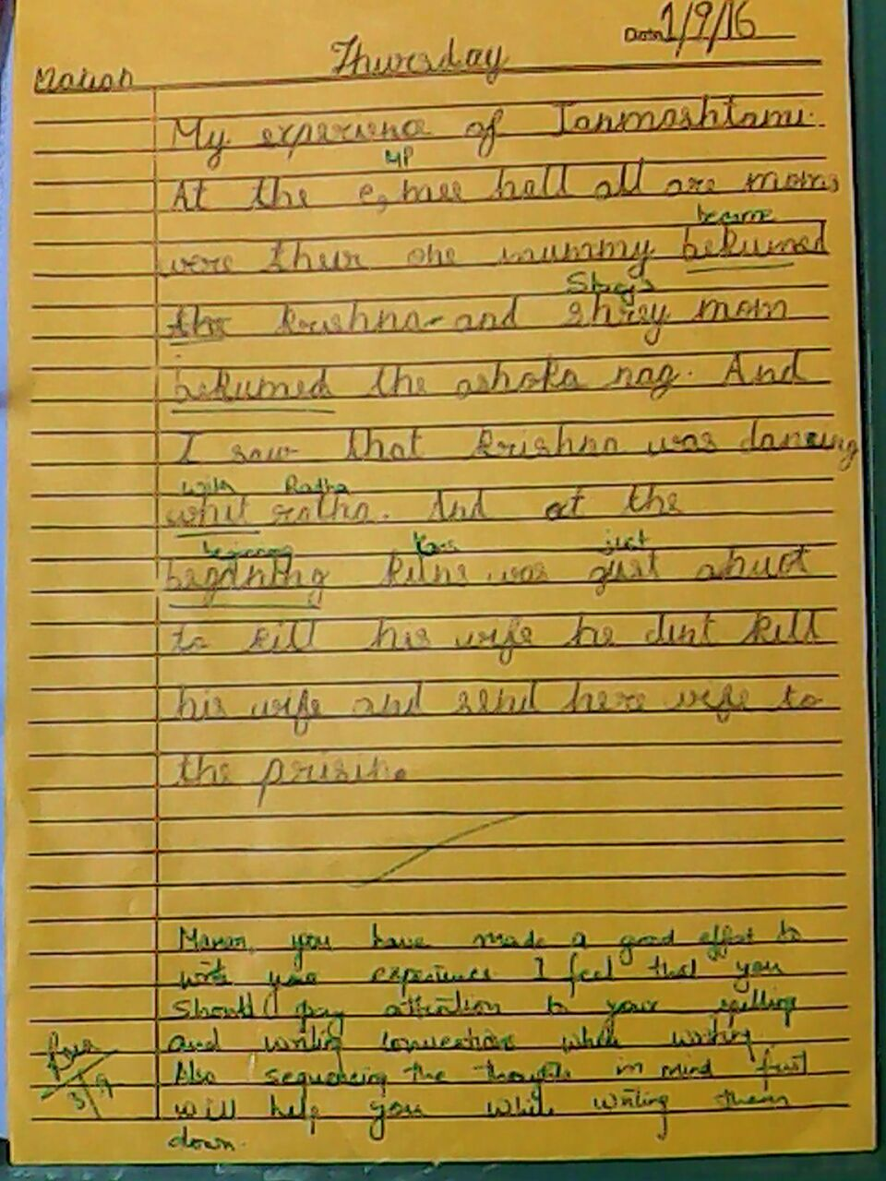

In the narrative he has just mentioned what he could visualize, but couldn’t connect it with his knowledge on Janmashtami. During Janmashtami we did so many activities and he didn’t mentioned any of them, which also shows that he don’t evaluate and check his work done, and gets satisfied very easily, this also shows that he could go through the whole picture but not the detailing of the same.

Teacher’s view about child: Manan is a pleasant and well-mannered child who works well in group. Although he listens attentively, his interpretation of the same lacks clarity. He is often assisted to comprehend the instructions despite the reiterations. Reinforcement and focus on the
Task at hand would help him produce work to the best of his ability. As he is on Progressive stage little push can help him to move to Meeting goals.

As I couldn’t speak to Manan’s parents so won’t be able to share their view on the same.

Way forward: I have felt Manan looks for help, he need little more attention in comparative to others. He also seeks for acknowledgements. As he just get lost in the middle of the session
And don’t listen whole instruction so extra check on his knowledge between the lessons will help him to be more attentive and for me as well to know whether he is getting the concept or not. I need to observe him more closely to understand his pattern of learning, so that I can help him to reach M from P.

